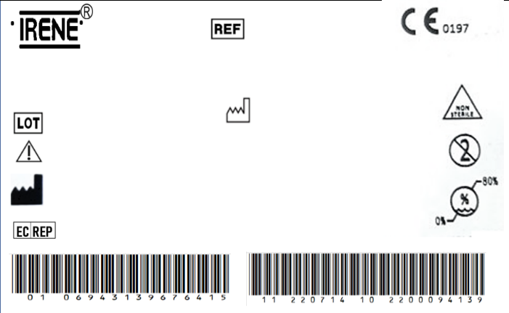

DIAMOND™ Cementless Acetabular Cup

T27410048

2300003007

2023/02/11

REGISTRO SANITARIO

5877-DME-1118

IMPORTADO Y DISTRIBUIDO POR ORTOMAX- PINEDA CORAL JAIRO DARIO

The implante should be sterilized before surgery.

TianJin ZhengTian Medical Instrument Co., ltd.

No. 318, Jingyi Road

Airport Economic Zone 300308 TianJin P.R. China

Bricon GmbH

EisenBahnstrasse 100, 78573 Wurmlingen, Germany

2028/02/10



DIAMOND™ Cementless Acetabular Cup

T27410048

2300003007

2023/02/11

REGISTRO SANITARIO

5877-DME-1118

IMPORTADO Y DISTRIBUIDO POR ORTOMAX- PINEDA CORAL JAIRO DARIO

The implante should be sterilized before surgery.

TianJin ZhengTian Medical Instrument Co., ltd.

No. 318, Jingyi Road

Airport Economic Zone 300308 TianJin P.R. China

Bricon GmbH

EisenBahnstrasse 100, 78573 Wurmlingen, Germany

2028/02/10